PERFORMANCE EVALUATION OF THE WILLIS SOLAR SYPHON
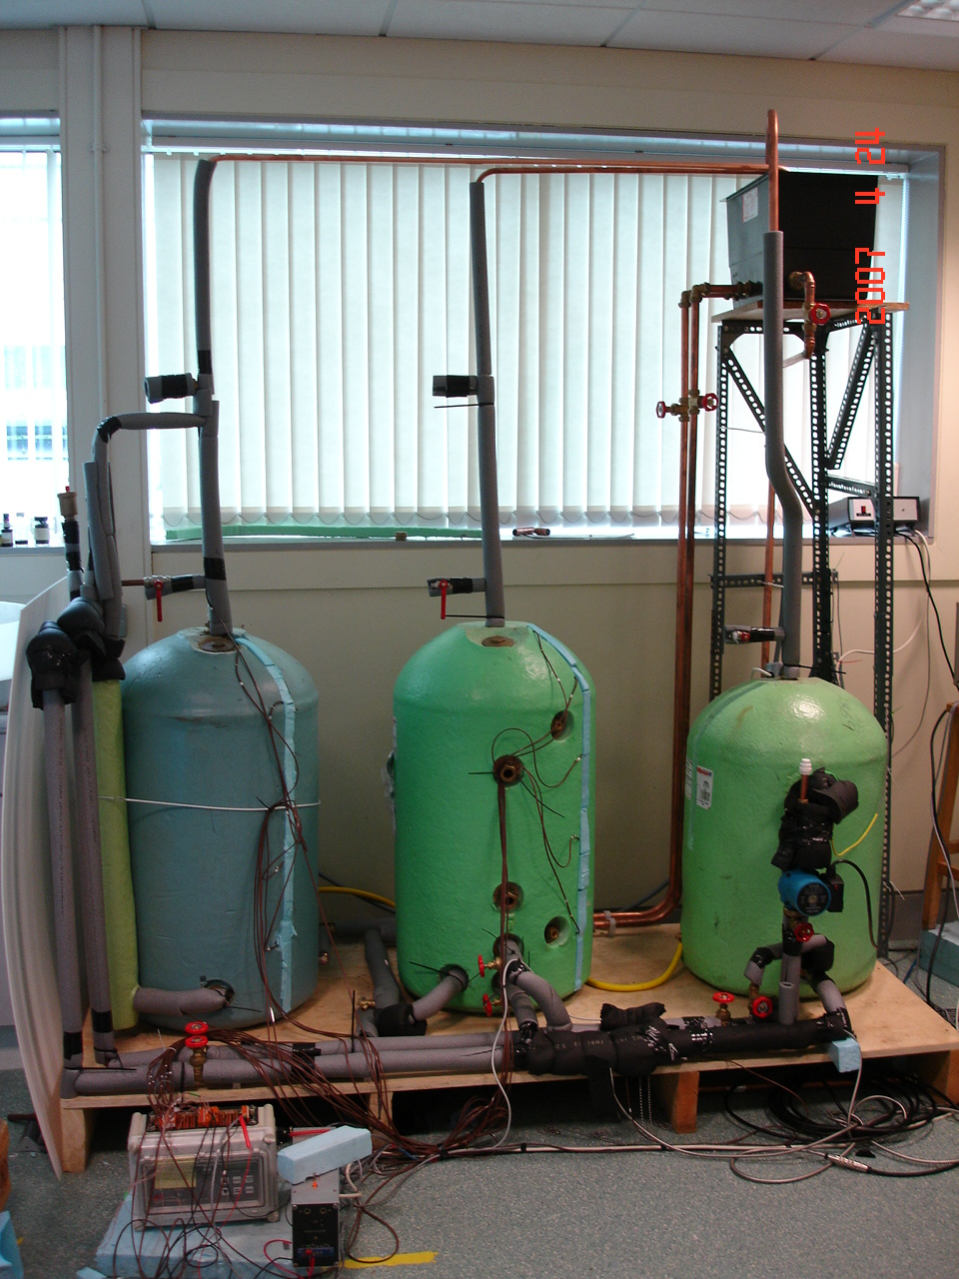

Report prepared by Dr Mervyn Smyth* and Dr Jayanta Deb Mondol

*Centre for Sustainable Technologies, Block 28A06, Sch Built Environment
University of Ulster at Jordanstown, Newtownabbey, BT37 0QB
Tel : 028 90368119, E-mail : m.smyth1@ulster.ac.uk

1. INTRODUCTION

The UK government in 1992, together with other developed countries, signed the Rio Convention that agreed to reduce the emissions of CO₂ to 1990 levels by the year 2000. In December 1997 the UK government signed up to the legally binding Kyoto Protocol to achieve at least a 5% reduction in CO₂ emissions below 1990 levels over the 2008-2012 periods. The UK emitted around 158 million tonnes of CO₂ (on a UNECE basis) in 2004, of which 47.4 million tonnes or 30% of the total was emitted by the domestic sector [Anon, 2005]. Approximately 22% of the domestic energy consumption in the UK is attributed to domestic water heating [Boyle, 1996], leading to 10.45 million tonnes of CO₂, in the UK based on 2004 values. The UK Government Energy White Paper 'Our Energy Future - Creating A Low Carbon Economy' published on 24th February 2003 sets out the long-term strategy for UK Energy Policy. Key aims are

- to cut the UK’s CO₂ emissions by 60% by 2050 with significant progress by 2020;
- to maintain the reliability of energy supplies;
- to promote competitive markets in the UK and beyond, helping to raise the rate of sustainable economic growth and to improve productivity; and
- to ensure that every home is adequately and affordably heated.

A typical solar water heating unit in the UK can reduce the domestic yearly hot water load by up to 40% [Smyth et al, 1999; Smyth et al, 2001], in a national context 4.17 million tonnes of CO₂ per year or roughly 2.64% of the total UK CO₂ emissions could be saved. The retro-fit solar water heating market represents the greatest single area where significant gains can be made in achieving this goal. The greatest barrier to their wide scale implementation is cost.

The distributed solar water heating system, using flat plate or evacuated collectors is, at present, the most common and widely used form of solar water heating in the UK. A crucial element in improving the economic viability of such units and hence reducing their likely payback period is the reduction in the component and installation costs and maximising the utilisation of the collected solar energy.

1.1 The Willis Solar Syphon

The Willis Solar Syphon system is a simple ‘bolt-on’ heat exchange unit, similar in concept to the Willis Immersion heater. The basic premise of the unit is to provide a lower cost installation alternative to traditional retro-fit solar water heating installations. The Willis Solar Syphon removes the need for a replacement twin coil storage tank, thus reducing costs whilst providing a high temperature input to the top of the hot water storage tank, where any solar gain can be more readily utilised, through an increased Solar Saving Fraction (S.S.F). The system is connected directly to the solar collector flow and return loop and through a novel heat exchange arrangement augmented by direct high and low connections made to the existing storage tank. Thermo-siphonic action is induced between the top and bottom of the tank, thus promoting rapid thermal stratification in the store when solar input is realised. Fig. 1 illustrates the working concept of the unit and Fig. 2 details the unit in a typical installed position.

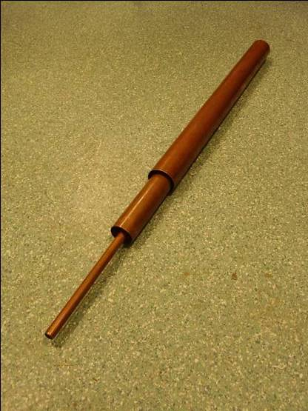
Cold water from storage cylinder in to heat exchanger
(a)
(b)
Hot water into the storage cylinder
Water return to solar collector from heat exchanger
Water from solar collector to heat exchanger
Fig.1 (a) Schematic section detail of the Willis Solar Syphon (b) Image of internal piping components of the solar syphon

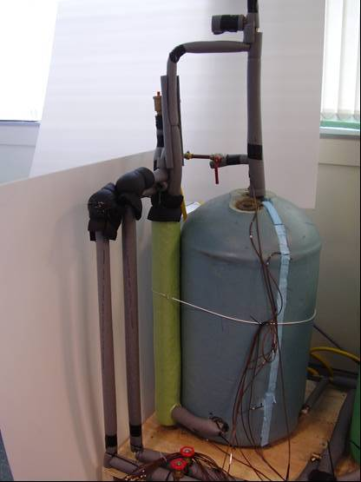
Standard direct or single coil indirect HWC
Willis Solar Syphon
Primary flow and return
High level secondary connection
Low level secondary connection

Fig. 2: Installed Willis Solar Syphon
1.2 Aims and Objectives

The aim of this investigation was to report upon the operating performance of the Willis Solar Syphon under controlled simulated conditions. The objectives of the study where to:
- gain an initial understanding of the Solar Syphon concept through meetings with the inventors to discuss set-up and installation parameters
- design, develop and install a suitable testing facility with flexibility and appropriate instrumentation,
- design and development of a rigorous test programme,
- implement the test programme,
- analyses test results and
- provide full documentation of the study.

2. DESCRIPTION OF THE TEST FACILITY

Following initial discussions with Willis Heating Ltd a suitable test facility was designed, developed and installed that would allow the full scope of the proposed investigation to be realised.

The test facility consisted of 3 hot water storage cylinders (HWC) mounted on a raised platform. Tank A was a direct HWC to which the Solar Syphon unit was attached. Tank B was an indirect twin coil HWC and was used for direct comparison with Tank A. Both tanks were of a similar specification apart from small variations due to requirements of the test programme. The third (primary) HWC was an electrically heated, directly connected vessel that could be thermally regulated to produce a suitable volume of hot water at a given temperature to represent a simulated thermal gain from a solar collector. Figs. 3 and 4 detail the storage tank set-up.
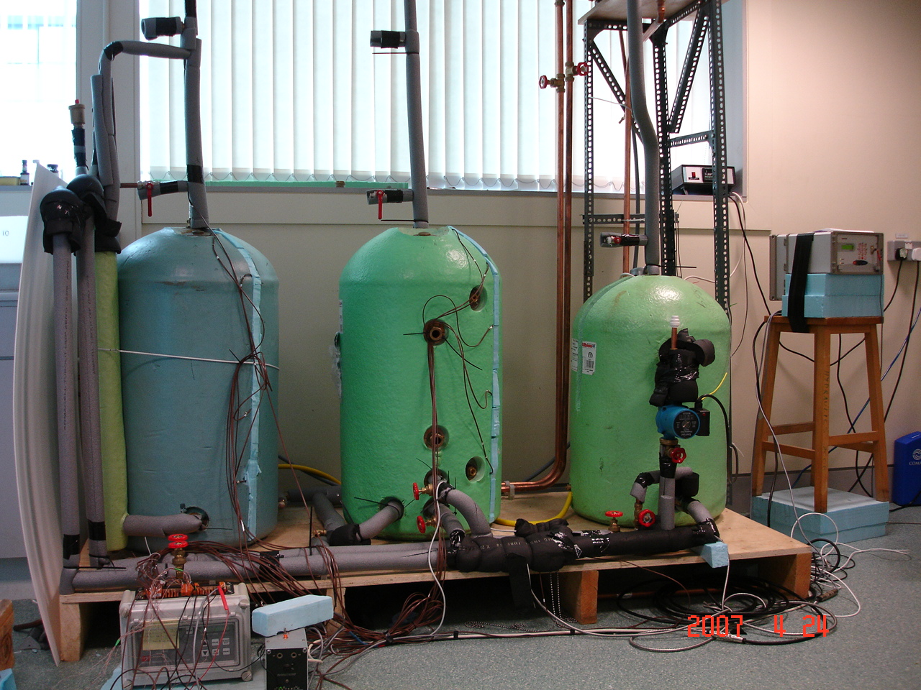
Tank A
Tank B
Primary HWC
Fig. 3 Storage tank arrangement
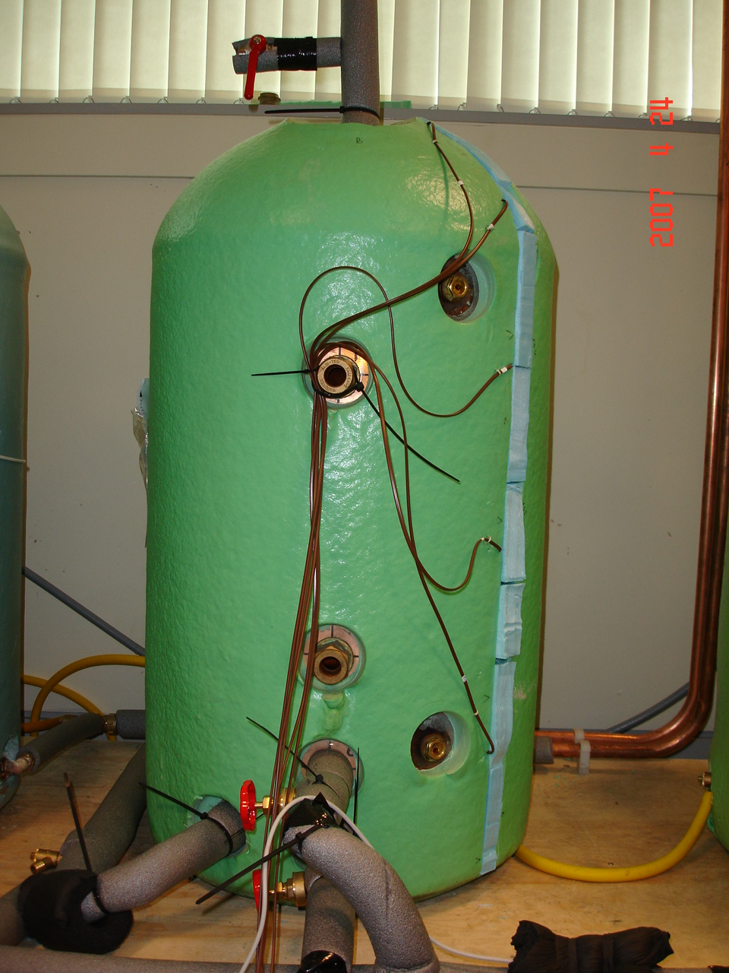
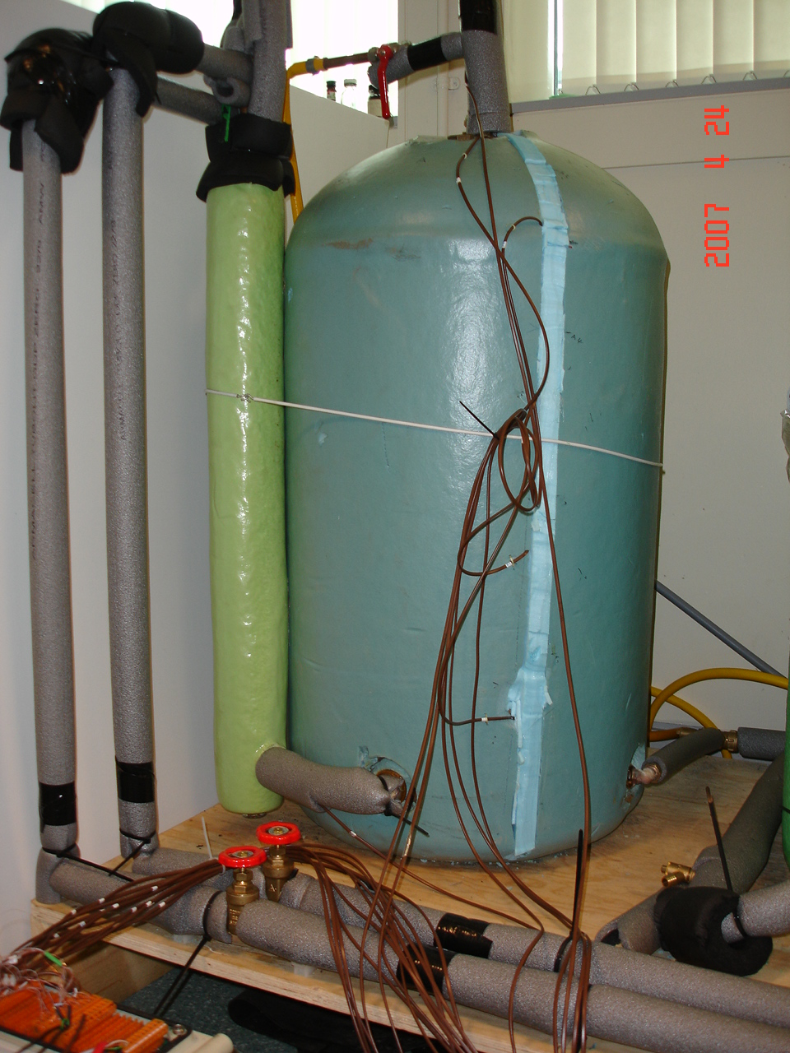
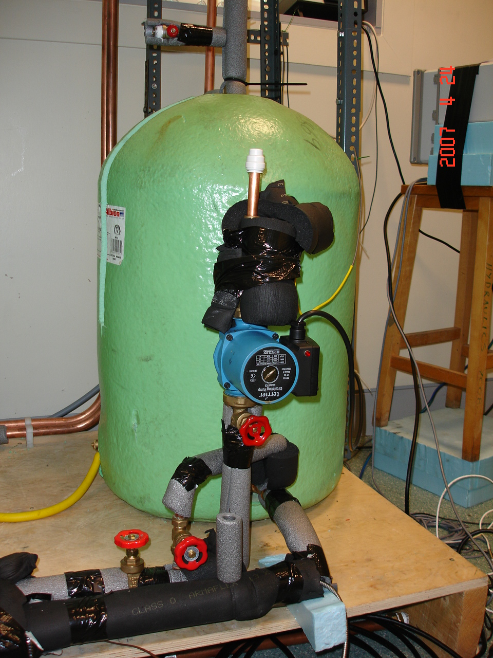
Fig. 4: Connection of the Storage tanks
Tank A
Tank B
Primary HWC

Through isolation valves, Tanks A or B could be independently isolated and/or tested by simulating solar gain through a pumped flow and return from the primary HWC. A bypass connection across the flow and return provided isolation of the primary HWC from Tanks A and B, but allowed continuous pumped flow through the primary HWC to produce uniform temperature distribution in the store, immediately before any test. Heat input to the primary HWC was via a 3kW immersion heater linked to a PID controller, providing control of the supply temperature in the primary loop. The bypass connection across the flow and return, with pump is shown in Fig. 5.

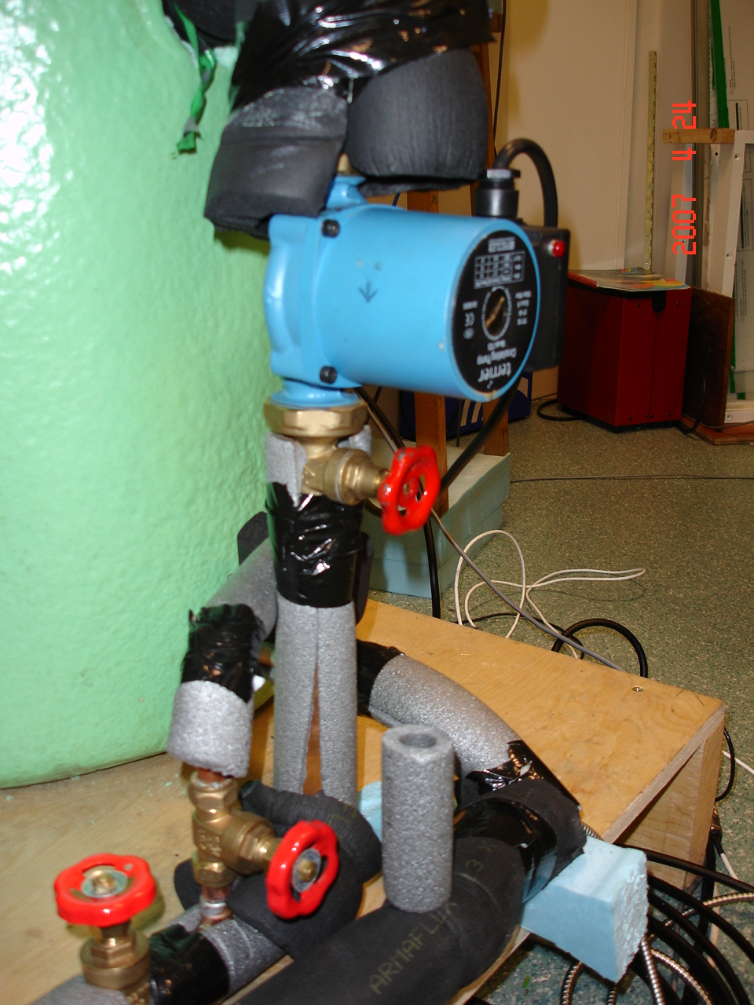
Fig. 5 Detail of the bypass connection across the flow and return, with pump

All HWCs were under constant gravity head at atmospheric pressure via the high level cold water feed tank, also providing system expansion. Storage Tanks A and B also had draw-off features to allow water to be drawn off and temperatures and flow rate monitored. Fig. 6 illustrates the cold water feed in arrangement and draw of outlets from HWC.

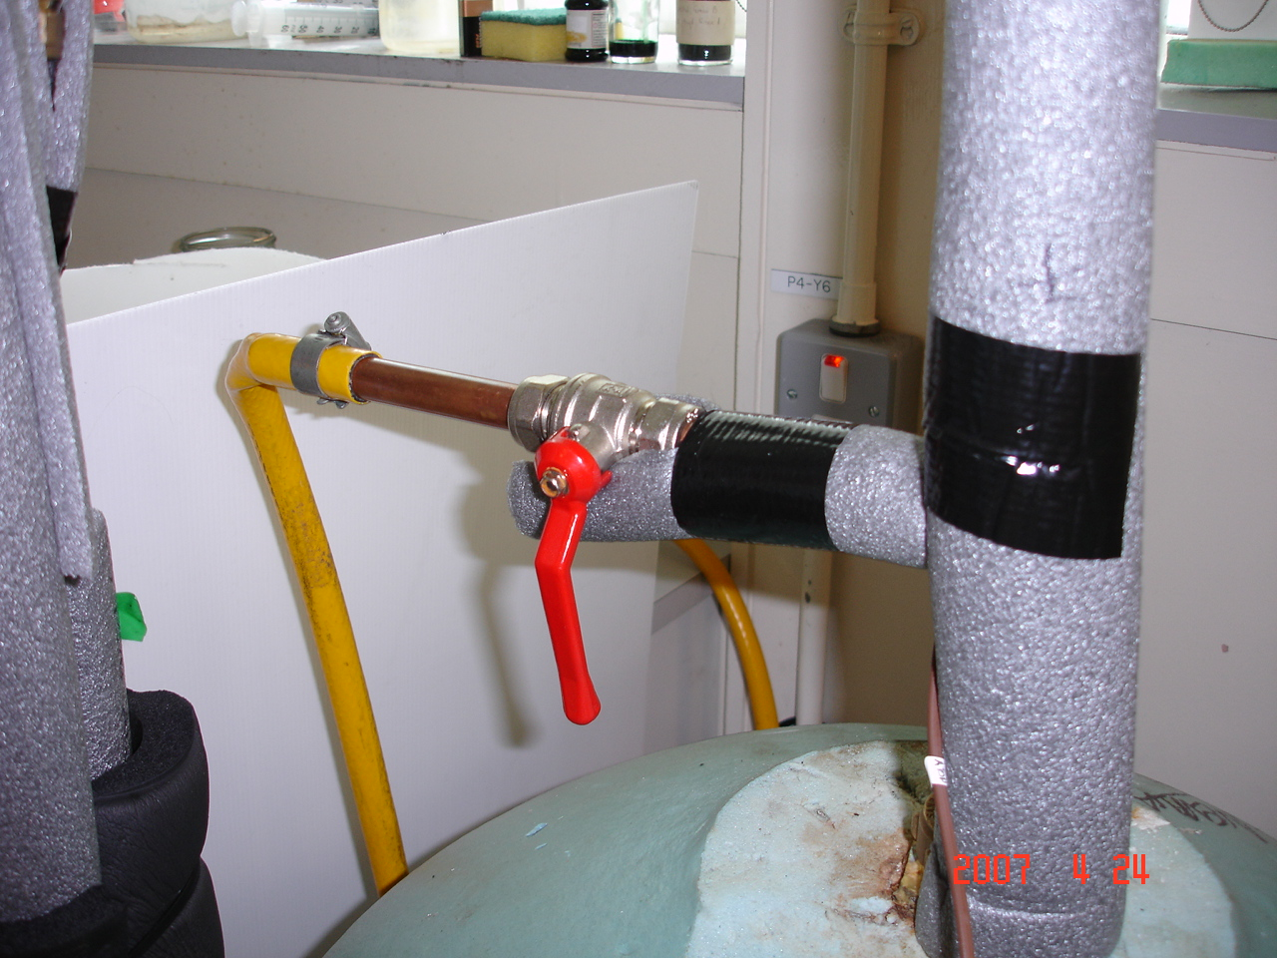
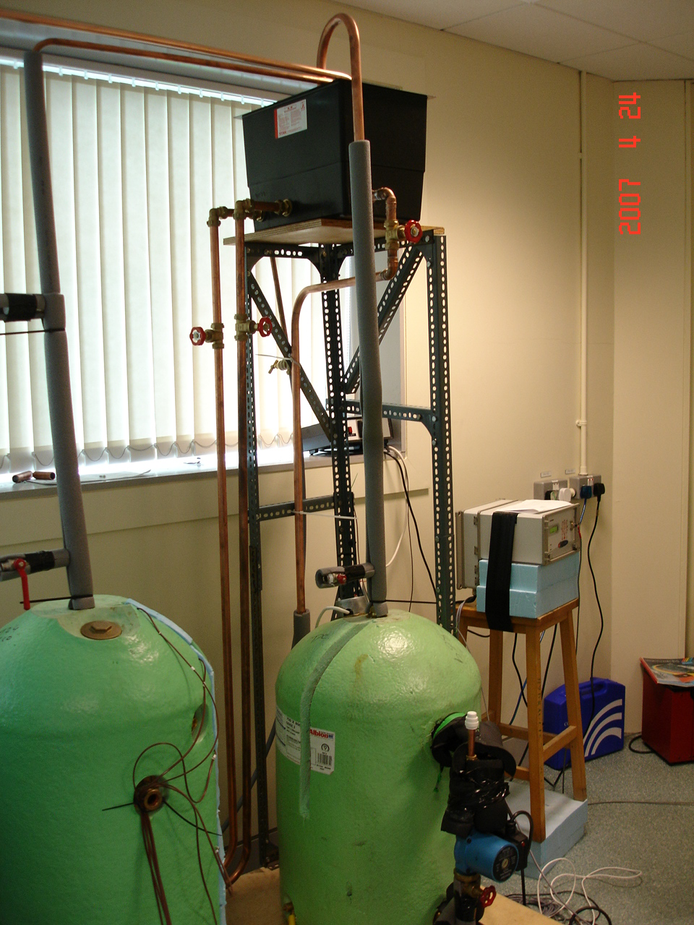
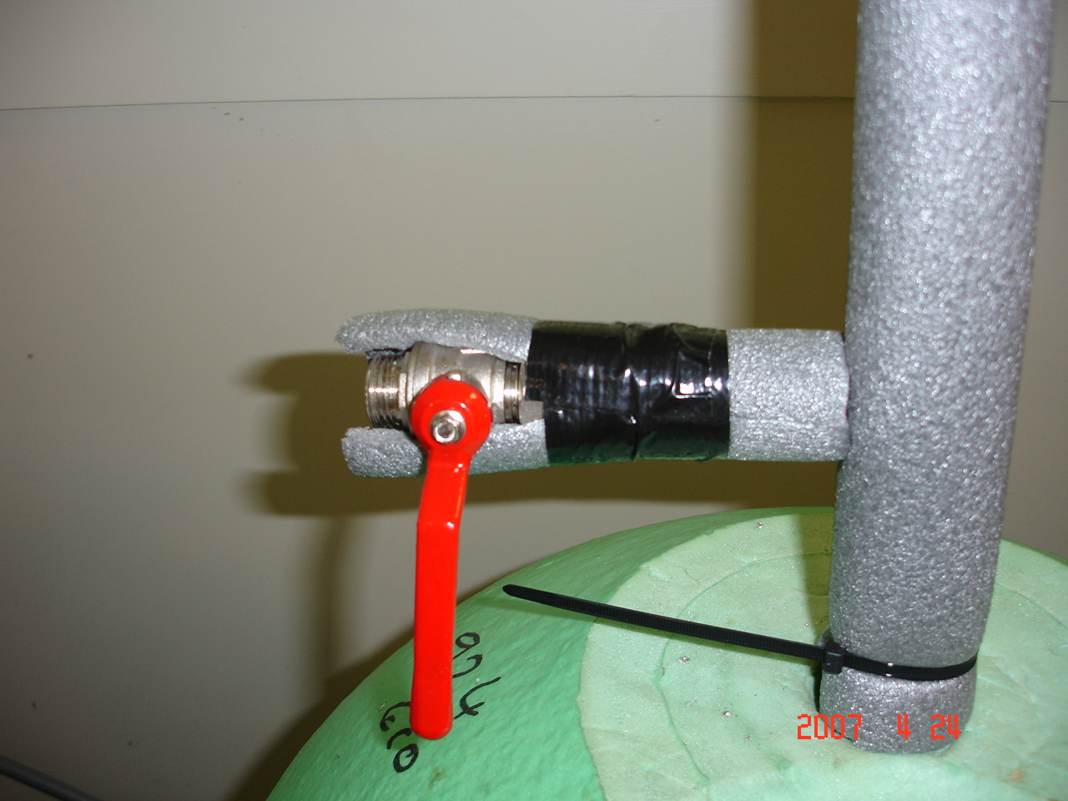
Fig. 6 Cold water feed and expansion tank (left) and draw-off outlets (right)

Thermocouples measured water flow and return temperatures in the primary ‘solar’ loop and secondary heat exchange loop, in addition to water temperatures in the HWCs, cold feed and hot outlet along with the ambient air temperature. Each of the secondary HWCs i.e., Tanks A and B, had temperature sensors placed at five locations to measure the variation of water temperature within each HWC. Pulse type flow meters were installed on the primary and secondary loops and an ultrasonic meter was installed close to the pump. All sensors were connected to a stand-alone Delta-T datalogger unit to record all measured variables. The datalogger was connected to a PC through a data transmission cable to transfer and store data in the PC. Fig. 7 schematically illustrates the test facility at the CST (Centre for Sustainable Technologies) laboratory, University of Ulster at Jordanstown.

Fig. 7 Schematic detail of the test facility

Water Tank
Temperature Regulator
Data Logger
Tank A
Tank B
Control
Storage B
A1
A2
A3
A4
A5
B1
B2
B3
B4
B5
T_{out}
T_{in}
Flow Metre
PC
Pump
Draw of outlet
Draw of outlet
Heat Exchanger
Water In
Both Tank A and Tank B have the same dimensions. Fig. 8 illustrates the dimensions and total volumes of water inside Tank A. The top volume (A1) contains 7.2 litres of water with water in the rest of the tank containing 112.4 litres, divided into four equal segments for temperature measurements. The volume of each segment is 28.1 litres. The tank was uniformly insulated to a depth of 30 mm.

28.1 Litres
28.1 Litres
28.1 Litres
28.1 Litres
7.2 Litres
A2
A3
A4
A5
A1
730 mm
165 mm

Fig. 8 Dimensions and volumes of Tank A

3. DESCRIPTION OF THE TEST PROGRAMME

Testing on the Willis Solar Syphon began in early February 2007 and was conducted over a 2 month period. Each test was carried out over a 3 to 6 hour heating/solar collection period and included water draw-off at the end of each test period. The range of test parameters examined where

- Primary HWC water supply temperature (solar simulated)
  - 50°C
  - 60°C
  - 70°C
- Secondary flow pipe entry position
  - high
  - low
- Primary HWC water supply pattern
  - continuous
  - intermittent
- Primary HWC water supply flow (pump condition)
  - Normal or restricted
  - Normal or reverse
- Draw off pattern
  - Single draw-off at test end
  - Intermittent draw-off during test

Where possible, all tests were duplicated for storage Tanks A and B, to allow direct comparisons to be made. Measurements of temperature and flow were taken every second, averaged and recorded every 1 minute. Draw-off variables were taken via manual measurement of flow and temperature.

4. RESULTS AND ANALYSIS

The temperature of water for both Tanks A and B were measured independently over 6 hours when the primary HWC temperatures were maintained at 50°C, 60°C and 70°C. Figs 9, 10 and 11 show the temperature profile of water inside Tanks A and B for these three cases. The water temperature in the upper volume of water (positions A1 and A2) in Tank A increases rapidly within a short period of time but the water temperature at the bottom of the tank (positions A4 and A5) increases less dramatically with time. This means that the rate of heat gain initially in the upper volume of Tank A is much higher than the lower volume. For Tank B, the heat gain rate is uniform throughout the whole volume of the tank resulting in a uniform temperature rise at any time within Tank B. After 6 hours of heat input, the average water temperature of Tank B is almost equal to the set temperature of the primary HWC. In Tank A, the water temperature at the base remained slightly lower than the set temperature. The heat transfer occurs between hot to cold water in Tank A through an external ‘bolt on’ heat exchanger. Cold water enters from the base of the solar syphon directly from the base of the HWC, is heated via the heat exchange surfaces and is returned back into the top of the HWC. This thermal syphonic action continues as long as a heat differential exists between the primary and the secondary loops. In Tank B, hot water in the primary loop is circulated via the twin coil located at the base of the HWC. Water adjacent to the coil is heated and through normal conductive and convective processes, thermal stratification develops within the HWC.

The temperature difference between inlet and outlet ports of Tank A was found to be 5°C during the initial heating period and decreased slowly with the increase in water temperature inside the tank. For Tank B, a large amount of heat was transferred from the primary loop to the secondary loop in the initial stages, producing a temperature differential of about 20°C between the inlet and the outlet ports (the primary HWC temperature was maintained at 50°C). This difference in temperature gradually decreased with time as the storage water temperature in Tank B increased.

The flow rates through Tanks A and B was measured using a pulse type flow meter. The number of pulses recorded every minute was divided by the constant provided by the flow metre manufacturer to obtain the volume of water flowing into the tanks. Fig. 12 illustrates the volume of water entering into Tank A and Tank B over a 6 hour period when the primary HWC temperature was maintained at 50°C and 70°C. Results indicate that there is no significant variation in flow rate between Tanks A and B. The average flow rate into Tank A and Tank B over a period of six hour was found to be 6.95 and 6.81 litres/minute respectively at 50°C and 6.64 and 6.55 litres/minute at 70°C.

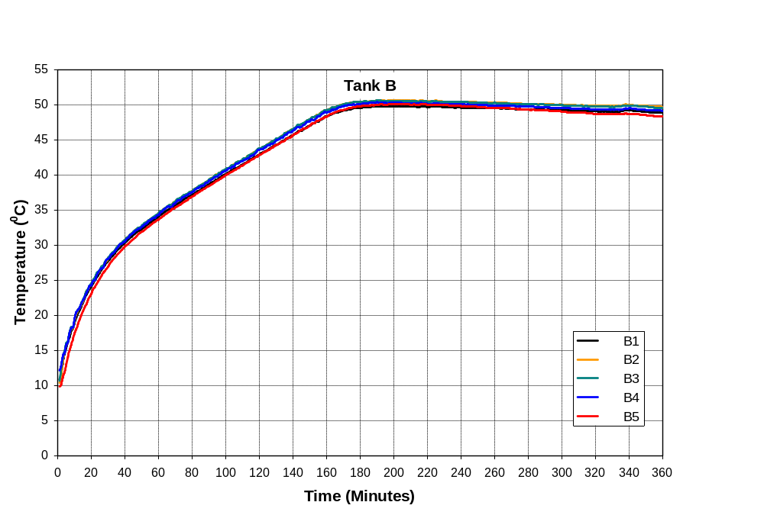
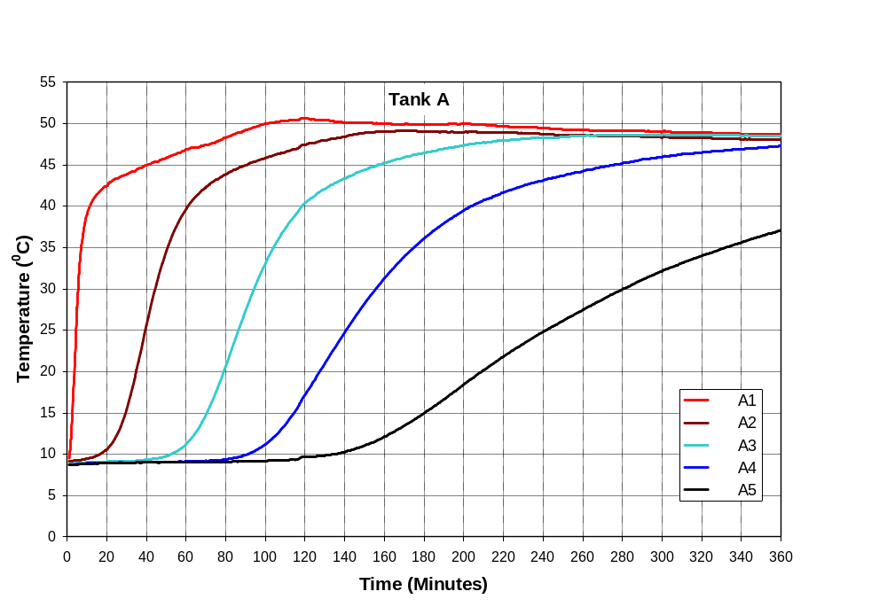
(a)
(b)

Fig. 9 Water temperature profiles for (a) Tank A and (b) Tank B over the 6 hour heating period when the primary storage tank temperature was maintained at 50°C
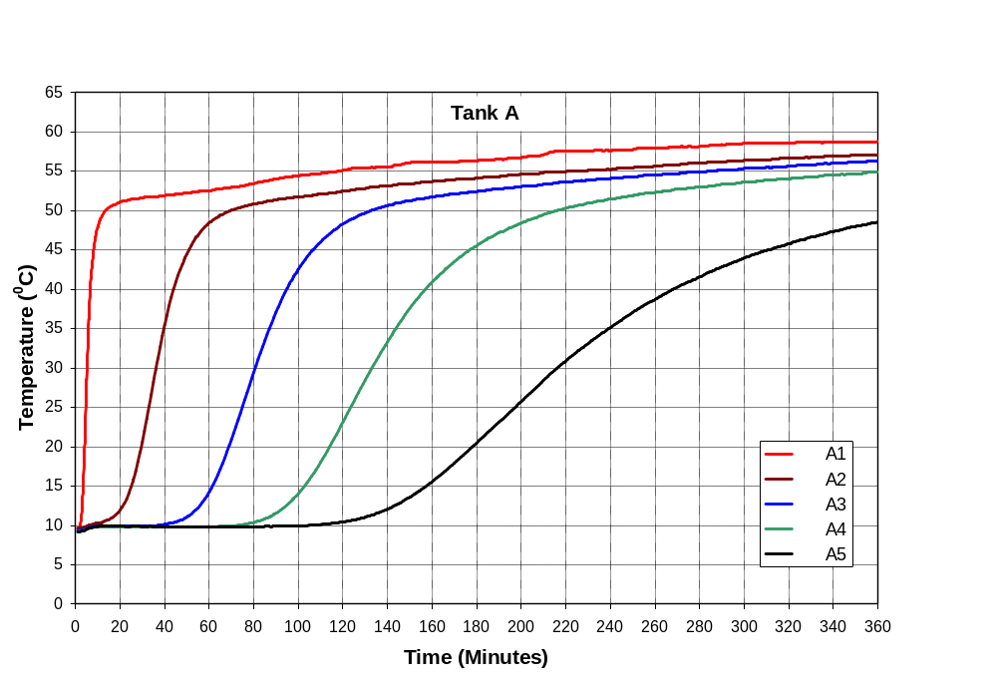
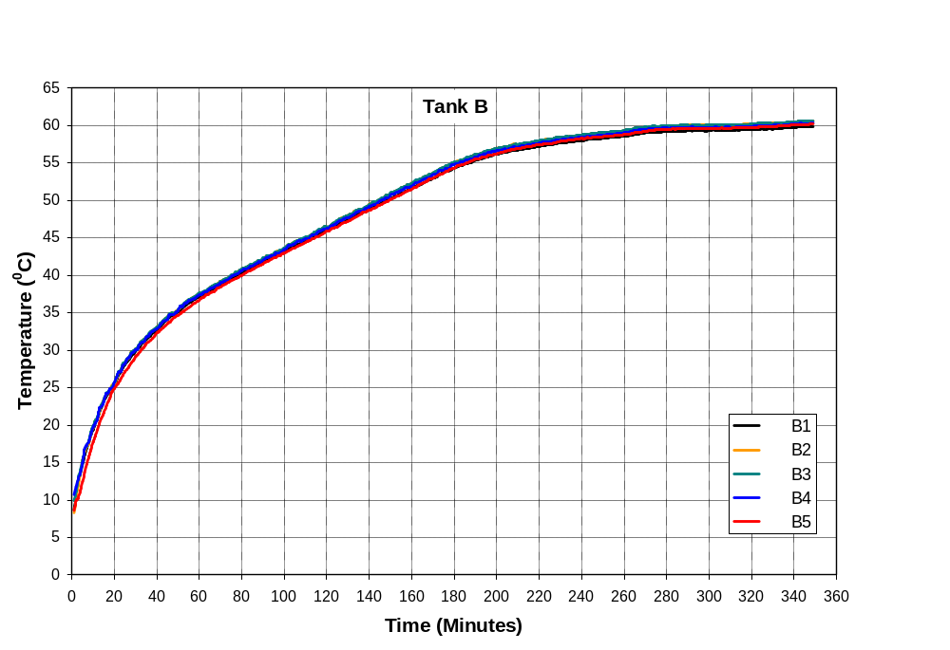
(a)
(b)

Fig. 10 Water temperature profiles for (a) Tank A and (b) Tank B over the 6 hour heating period when the primary storage tank temperature was maintained at 60°C

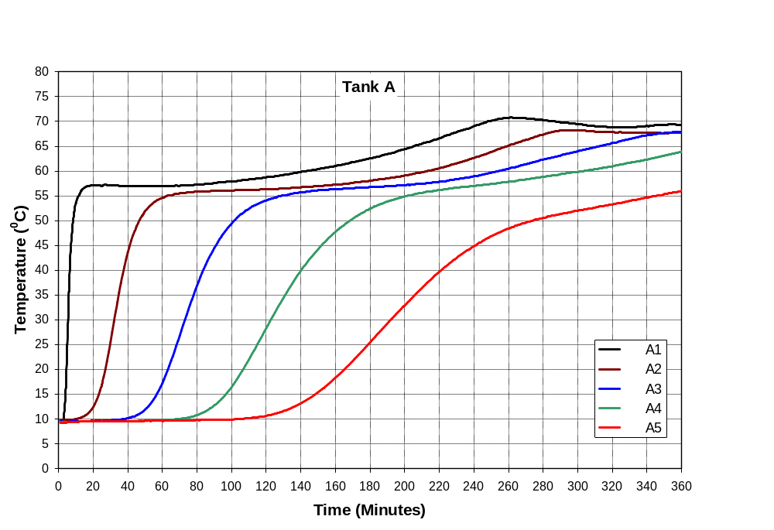
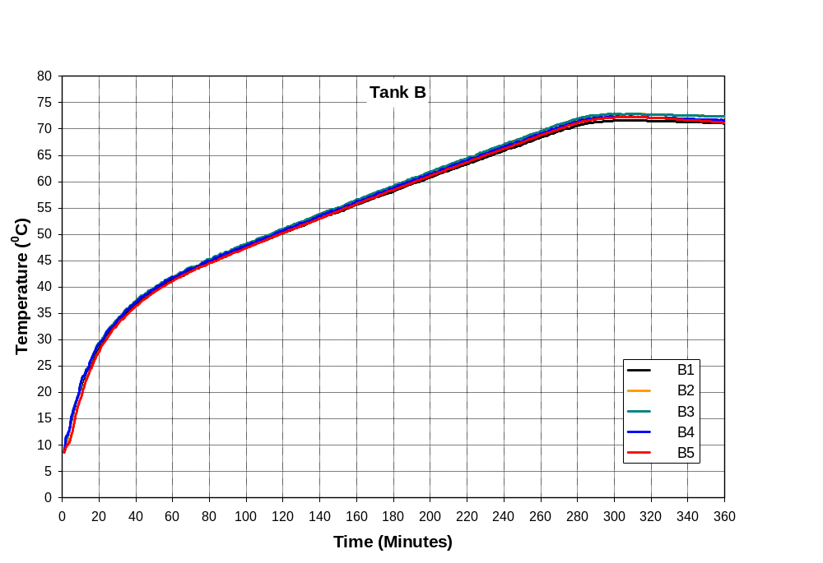
(a)
(b)

Fig. 11 Water temperature profiles for (a) Tank A and (b) Tank B over the 6 hour heating period when the primary storage tank temperature was maintained at 70°C

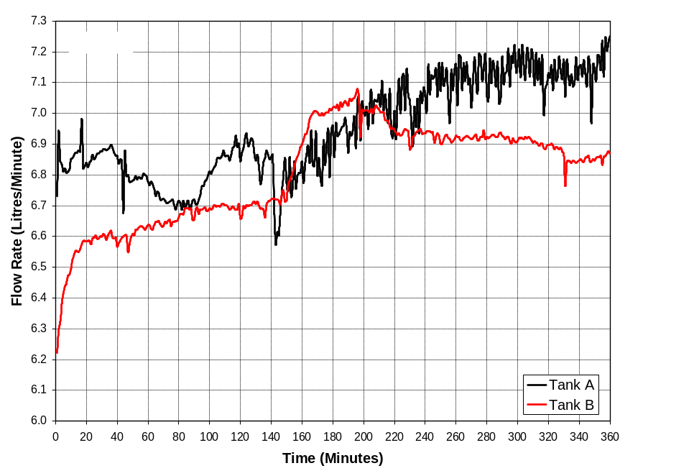
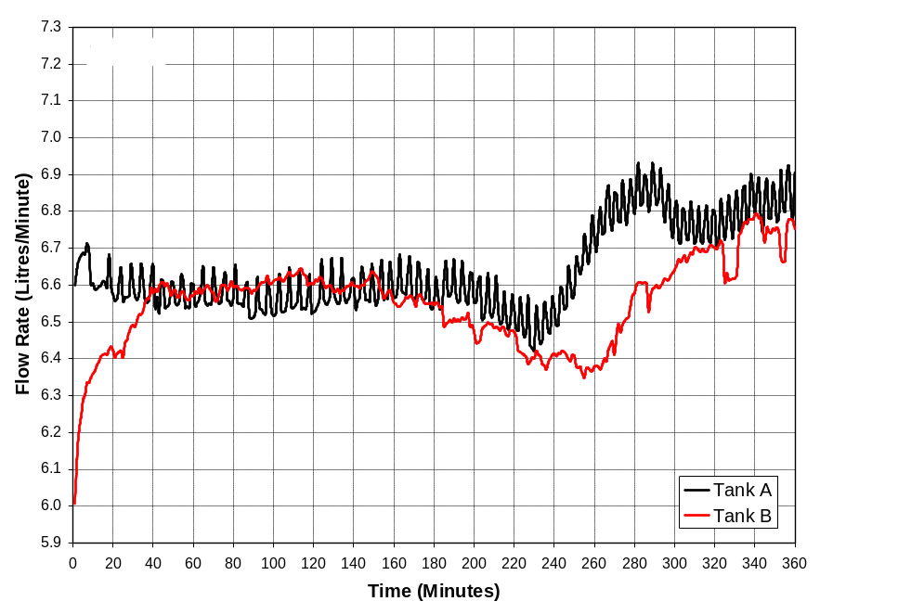
Fig. 12 Comparison of flow rates between Tanks A and B for the primary HWC temperatures of; (a) 50°C and (b) 70°C

The experimental investigation also examined the effect of secondary flow pipe entry position on the performance of Tank A in terms of heat gain. The height of the secondary flow pipe was varied between a high and low position. The test results show that there is no significant impact on the heat gain efficiency of Tank A due to the variation of the position of the secondary flow pipe.

To compare the performance of both tanks, the average water temperature of each tank was used to determine the heat gain. Two sets of average water temperatures were considered. The first temperature set was based on the 35.3 litres of water (see Fig. 8) contained within the upper volume of the tanks. The second temperature set considered the total water volume within the tanks representing 119.6 litres of water. The average water temperatures of the upper and total volumes of Tanks A and B for three differing primary HWC temperatures are shown in Fig. 13. For all cases the temperature of the upper volume of water in Tank A is higher than Tank B within the first 3 hours. This indicates a significantly improved S.S.F where small volumes of hot water are required within relatively short heating periods. Although in terms of average temperature for the total water volume contained within each tank, Tank B has a better performance as the average water temperature of Tank B is higher than Tank A. Subsequently the amount of total heat gain by Tank B over a 6 hour period is greater than that in Tank A.

The heat gain in both tanks over the 6 hour period was estimated using equation 1.

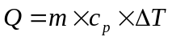 [eq 1]

where Q: heat gain (Kcal)
m: mass of water (kg)
c_{p}: specific heat constant (Kcal/kg/K)
ΔT: temperature difference (K)

The rate of heat gain in Tanks A and B is shown in Fig. 14. The amount of heat gain in the upper volume of Tank A increases gradually and reaches its peak after one hour whereas in Tank B the maximum heat gain occurs within the first half an hour. The amount of heat gain in Tank B is lower compared to Tank A within a two hour period but after two hours the amount of heat gain by Tank B is higher than Tank A resulting in a similar total heat gain over a 3 hour period. The total amount of heat gain by Tanks A and B over the 3 hour period was found to be 1413 and 1375 Kcal, respectively with a primary HWC temperature of 50°C, 1576 and 1574 Kcal with a primary HWC temperature of 60°C and 1711 and 1707 Kcal with a primary HWC temperature of 70°C.

The heat gain efficiency of Tanks A and B was calculated based on the amount of heat input and heat gain over the six hour period. When the heat gain efficiency for both tanks was calculated considering only the upper volume of the tank, Tank A shows better performance than Tank B as shown in Fig 15. In the first 3 hours of heating, the heat gain efficiency of Tank A gradually decreases while the heat gain efficiency of Tank B remains constant within the same time period. However the results also suggests that within the first hour of heating, as the primary HWC water temperature increases, the heat gain efficiency of Tank A is better than that of Tank B indicating a more efficient utilisation of solar heat gain into the upper volume of the tank.

However when the heat gain efficiency was calculated considering the whole volume of the tanks, Tank B performs better than Tank A as shown in Fig 16. For primary HWC temperatures of 50°C, 60°C and 70°C, the efficiencies of Tank A are 62.1%, 81.3% and 81.4%, respectively and for Tank B 71.8%, 89.7% and 88.0%.

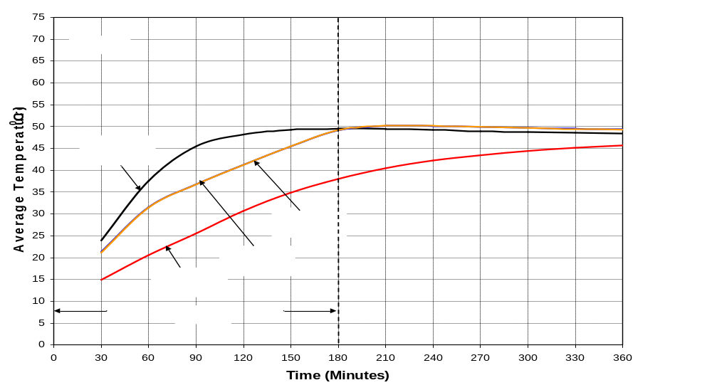
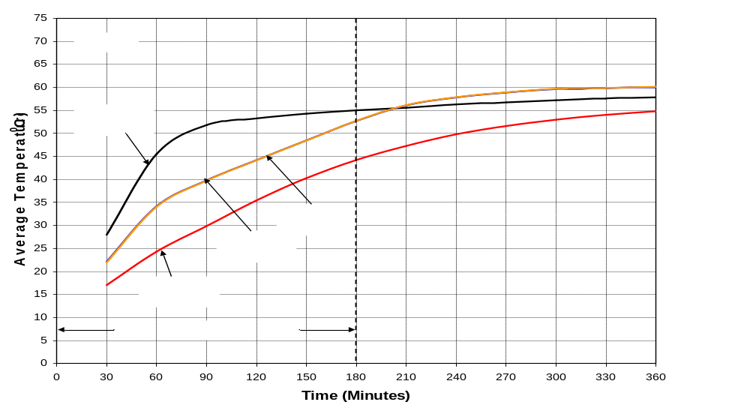
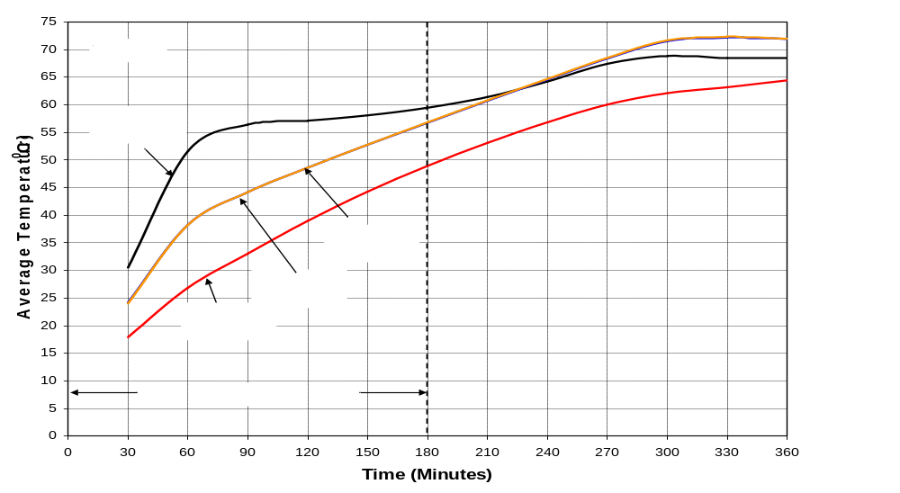
(a)
(b)
(c)

Fig. 13 Average water storage temperatures for Tanks A and B over the 6 hour heating period when the primary storage tank temperature was maintained at (a) 50°C, (b) 60°C and (c) 70°C
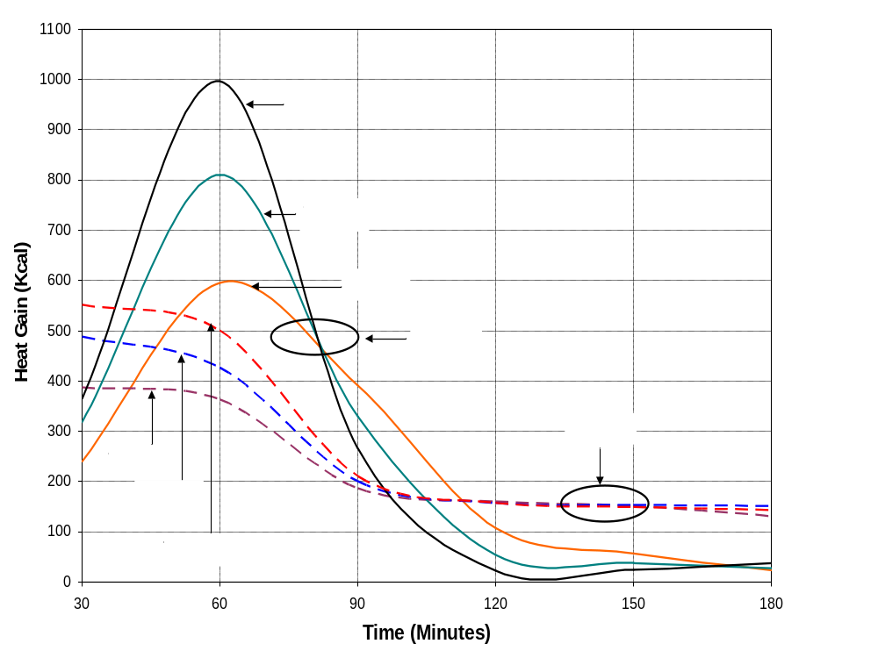
Fig. 14 Comparison of total heat gain in the upper tank volume with respect to the time

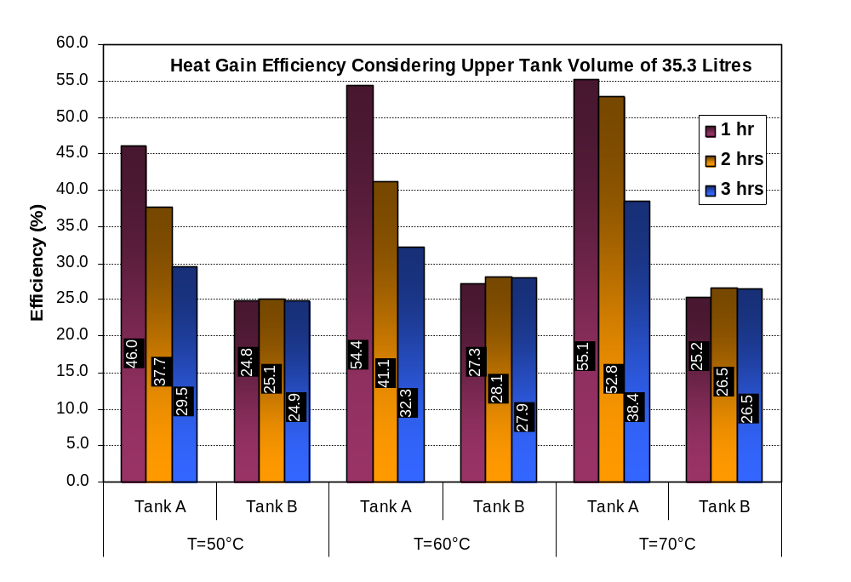

Fig 15 Heat gain efficiency in the upper volume of Tanks A and B when the primary storage tank temperatures were maintained at 50°C, 60°C and 70°C
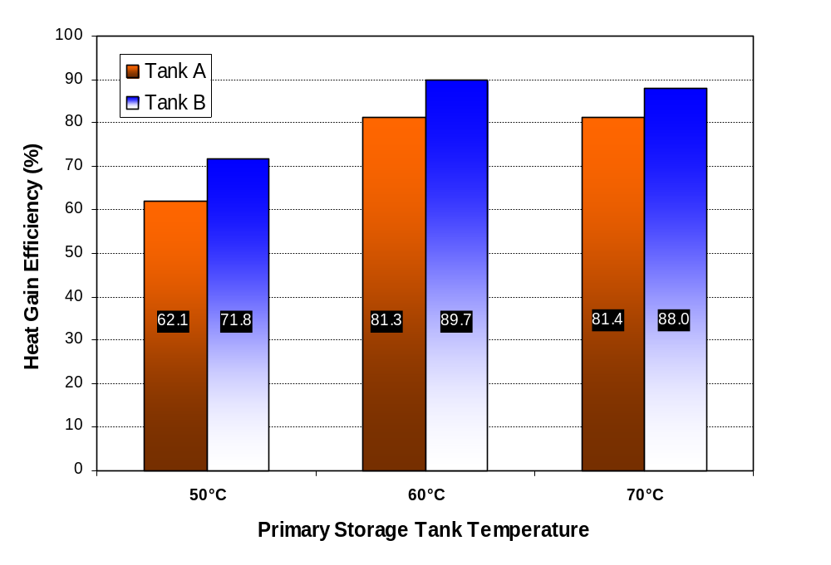
Fig 16 Overall heat gain efficiencies of Tanks A and B for primary storage tank temperatures of 50°C, 60°C and 70°

Table 1 shows the amount heat gain by Tank A and Tank B at 1 hour intervals over a 3 hour period for different primary HWC set up temperatures. The results indicate that Tank A is more efficient compared to Tank B when the heat gain in the upper volume of the tanks were considered. The heat gain by Tank A is higher than Tank B within the first two hours of the experiment. The amount of heat gain by Tank A is 11.6% to 29.6% and 16.4% to 21.9% higher than Tank B over first and second hours respectively. However over a 3 hour period the amount of heat gain for both tanks is almost equal. The results suggest that the temperature of the water contained in the upper volume of Tank A increases more quickly than Tank B, which indicates a better SSF for limited draw-off scenarios. However for longer heating periods and sustained draw-off conditions Tank B is more effective than Tank A in terms of total heat gain.

Time | Primary HWC Temperature | Tank A |  | Tank B |  | Percentage Heat Gain by Tank A over Tank B  (%)
Time | Primary HWC Temperature | Upper Volume  (Litre) | Heat Gain  (Kcal) | Upper Volume  (Litre) | Heat Gain  (Kcal) | Percentage Heat Gain by Tank A over Tank B  (%)
1 hr | 50°C | 35.3 | 836 | 35.3 | 749 | 11.6
1 hr | 60°C | 35.3 | 1129 | 35.3 | 914 | 23.5
1 hr | 70°C | 35.3 | 1362 | 35.3 | 1051 | 29.6
2 hrs | 50°C | 35.3 | 1333 | 35.3 | 1094 | 21.9
2 hrs | 60°C | 35.3 | 1512 | 35.3 | 1270 | 19.1
2 hrs | 70°C | 35.3 | 1649 | 35.3 | 1417 | 16.4
3 hrs | 50°C | 35.3 | 1413 | 35.3 | 1375 | 2.8
3 hrs | 60°C | 35.3 | 1576 | 35.3 | 1572 | 0.3
3 hrs | 70°C | 35.3 | 1711 | 35.3 | 1707 | 0.2

Table 1 Heat gain by Tank A over Tank B for three primary hot water tank temperatures and three time intervals
To simulate the effect of a variable solar input and determine the performance of each tank, the pump and heater were periodically switched on and off at 30-minute intervals over a period of 12 hours. Fig. 17 illustrates the rise in water temperature in Tanks A and B over 12 hours when the primary HWC temperature was kept at 50°C. The results indicate that the upper volume of water in Tank A maintains higher temperature than Tank B over a period of 6 hours. The temperature of the water at the bottom of the tank is lower than the upper volume and steadily increases with time whereas in Tank B the water temperature of the total tank increases uniformly and is constant throughout the test period.

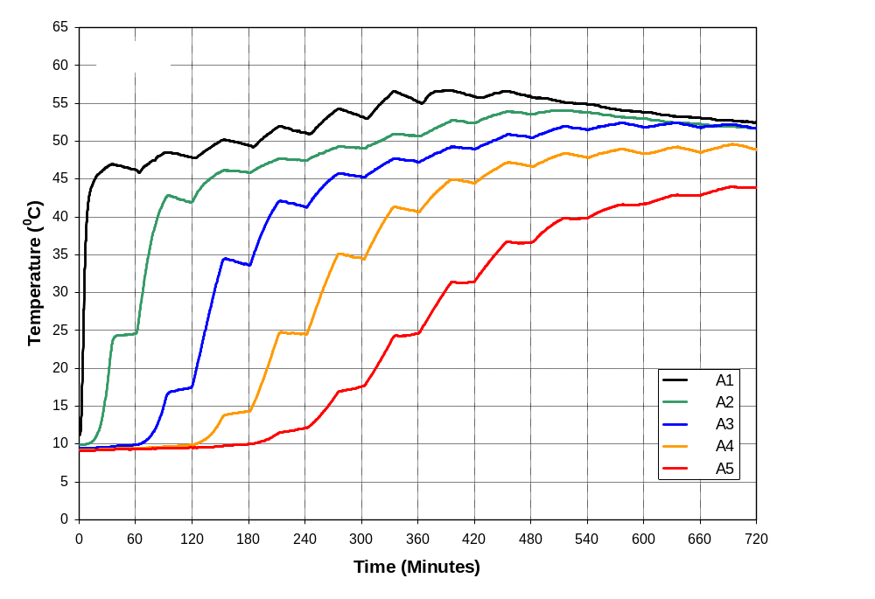
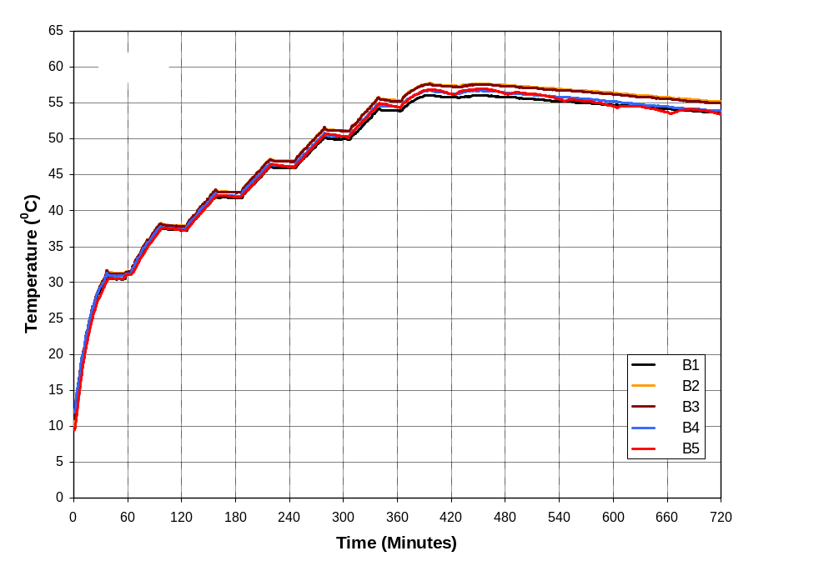
(a)
(b)
Fig. 17 Water temperature over a period of 12 hours in (a) Tank A and (b) Tank B when the heater and the pump were periodically switch off and on at 30-minute intervals
To simulate the effect of intermittent draw off of hot water from the storage tanks, a fixed volume of water was drawn intermittently from both tanks at fixed time intervals. Two experiments were conducted, one at 20 litres of water drawn every 30 minutes and the other were 40 litres drawn every 60 minutes. Figs. 18 and 19 illustrate the temperature profile of the water inside both storage tanks. The results indicate that the water temperature in the upper volume of Tank A was significantly affected due to drawing of water, whilst in Tank B, the temperature of the lower volume of water decreases due to mixing of cold water into bottom of the tank. The temperature at the upper volume of Tank A (A1) reached constant temperature of 45°C for each draw whereas for Tank B the temperature gradually increased from 34°C to 52 °C over 6 hour period when 20 litres of water drawn at 30-minute intervals.

Table 2 and Fig. 20 detail the average temperatures of collected water from both tanks when 20 litres of water was drawn at 30-minutes intervals. Table 3 and Fig. 21 are the average temperature of collected water from both tanks when 40 litres of water was drawn at 60-minutes intervals. The temperature of water collected from Tank A remained the same over the six hour period and only varied by 43.2°C to 44.9°C. In Tank B the temperature of the collected water increased gradually from 32.8°C to 50.8°C when 20 litres of water was drawn at 30-minute intervals. When 40 litres of water was drawn at one hour intervals, the average temperature of the collected water from Tank A is higher than Tank B. The temperature of the water collected from Tank A ranged from 40.9°C to 49.3°C and for Tank B from 31.9°C to 50.9°C. The results indicate that Tank A for intermittent draw-off of water within short periods of time provides water at temperature higher than Tank B.

At the end of each 6 hour test, the temperature and flow rate of the water drawn from Tanks A and B were measured and recorded. Fig. 22 shows the difference between the temperature of water drawn from Tank A and Tank B with respect to the volume of water drawn for primary HWC temperatures at 50°C, 60°C and 70°C. The results indicate that a greater amount of water with a higher temperature can be drawn from Tank B when compared to Tank A.
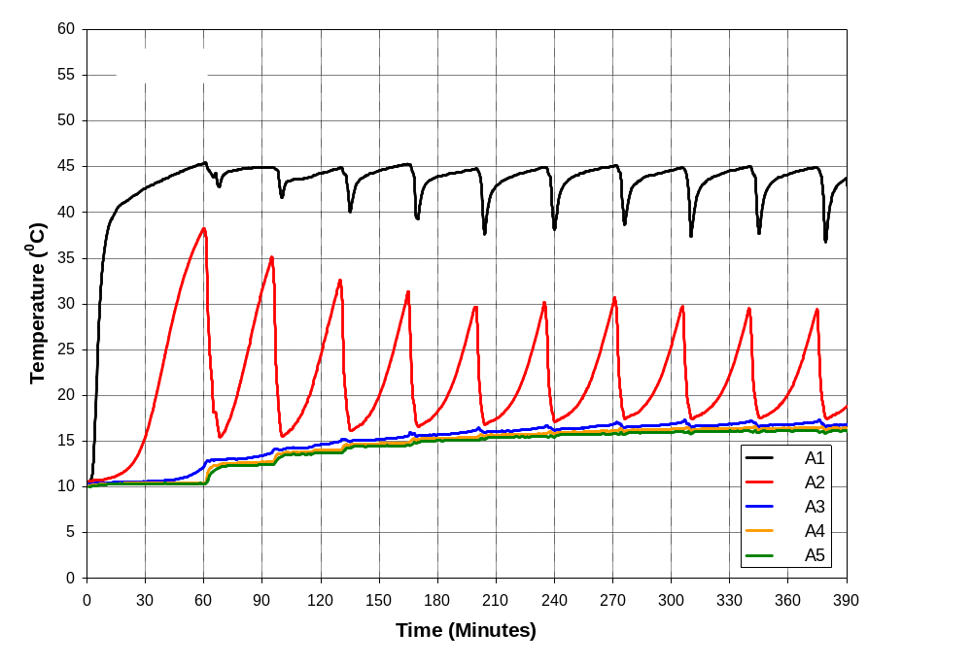
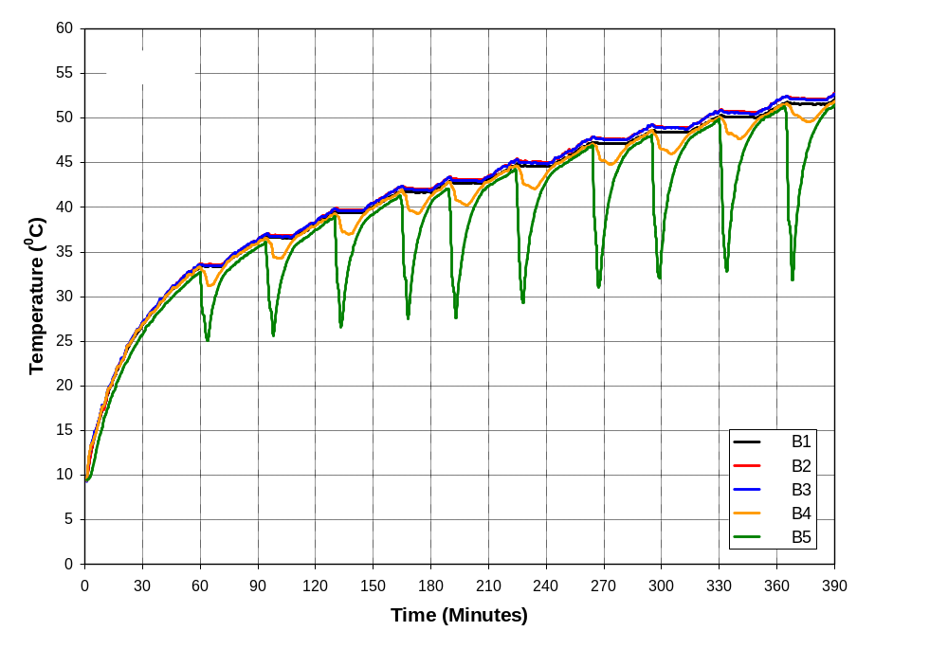
Fig. 19 Temperature distribution over the 6 hour period when 20 litres of water was drawn at 30-minute intervals with a HWC supply temperature 50 °C: (a) Tank A and (b) Tank B
(a)
(b)

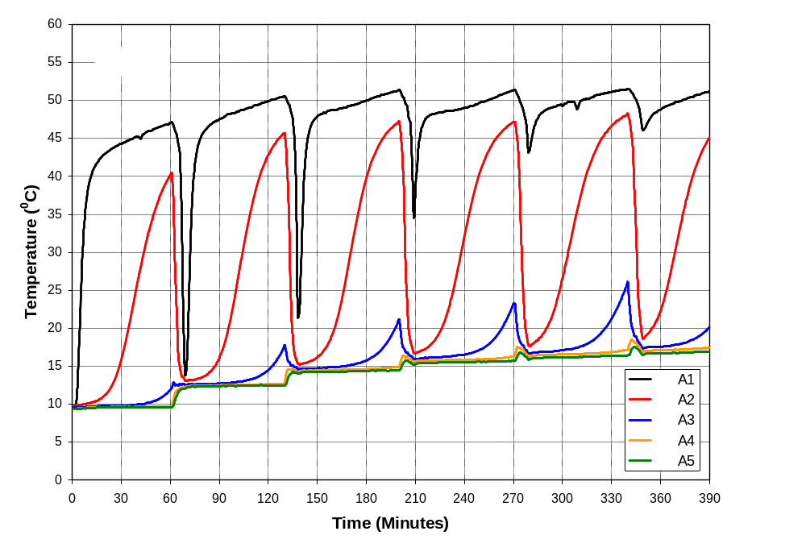
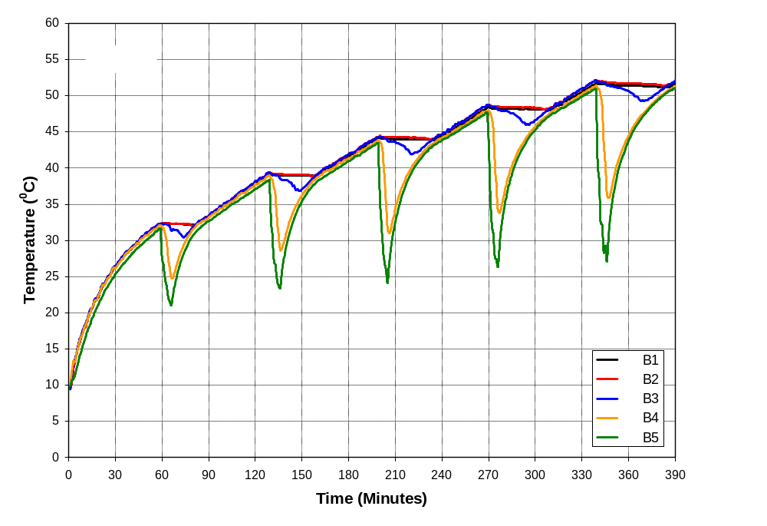
Fig. 19 Temperature distribution over the 6 hour period when 40 litres of water was drawn at 30-minute intervals with a HWC supply temperature 50 °C: (a) Tank A and (b) Tank B
(a)
(b)

Time  (Minutes) | Amount of Water Collected  (Litres) | Average Water Temperature  (°C)
Time  (Minutes) | Amount of Water Collected  (Litres) | Tank A | Tank B
30 | 20 | 44.9 | 32.8
60 | 20 | 44.0 | 36.1
90 | 20 | 43.3 | 38.8
120 | 20 | 43.8 | 41.2
150 | 20 | 43.2 | 42.2
180 | 20 | 43.3 | 44.2
210 | 20 | 43.6 | 46.6
240 | 20 | 43.2 | 47.8
270 | 20 | 43.3 | 49.4
300 | 20 | 43.3 | 50.8

Table 2: Average temperature of collected water for 20 litres draw-off every 30 minutes

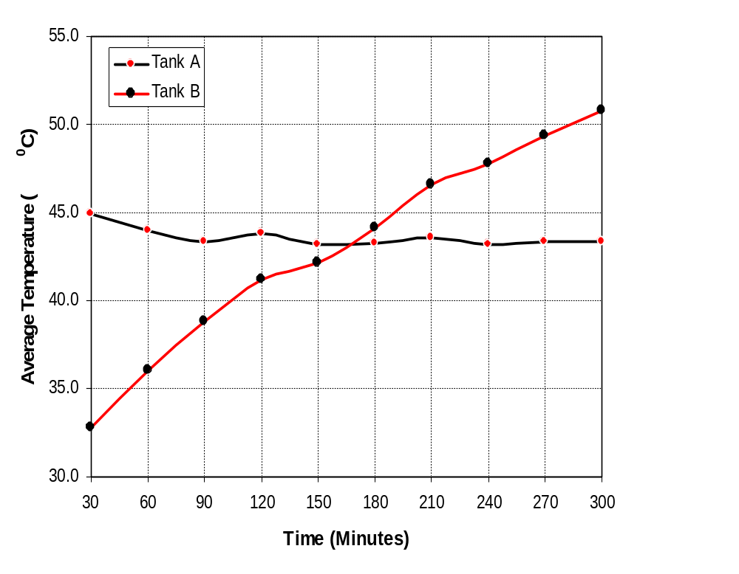
Fig 20 Average draw-off water temperatures from Tanks A and B when 20 litres of water was collected at 30-minute intervals

Time  (Minutes) | Amount of Water Collected  (Litres) | Average Water Temperature  (°C)
Time  (Minutes) | Amount of Water Collected  (Litres) | Tank A | Tank B
60 | 40 | 40.9 | 31.9
120 | 40 | 47.0 | 38.5
180 | 40 | 48.7 | 43.5
240 | 40 | 49.0 | 47.6
300 | 40 | 49.3 | 50.9

Table 3 Average temperature of collected water for 40 litres draw-off every 60 minutes

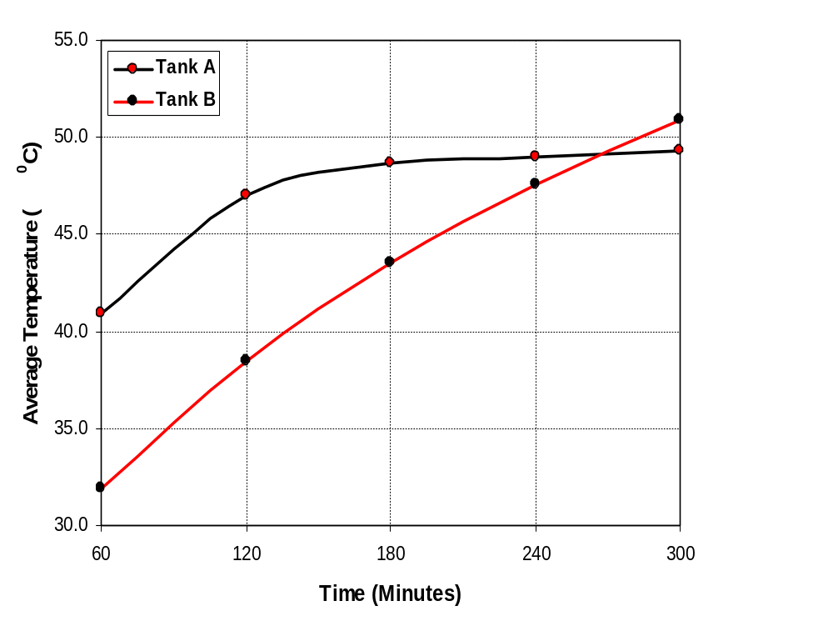

Fig. 21 Average draw-off water temperatures from Tanks A and B when 40 litres of water was collected at 60-minute intervals

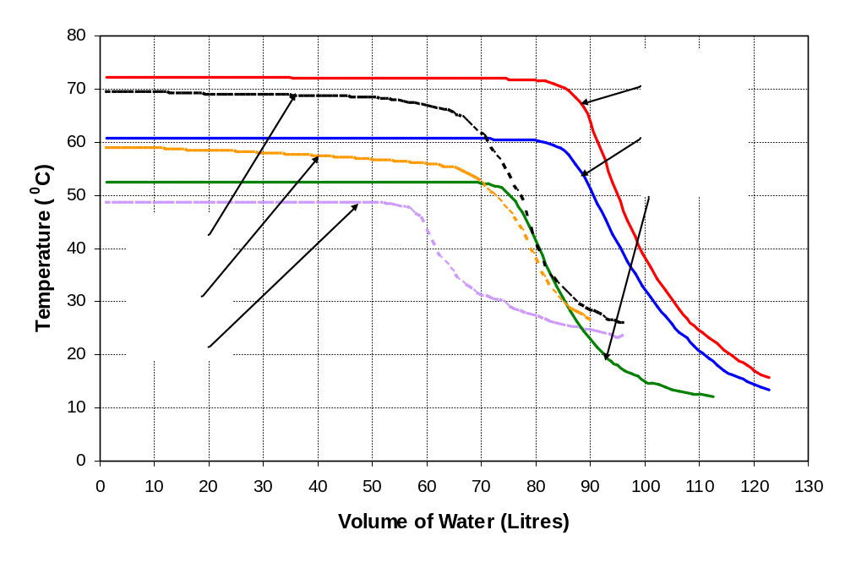
Fig. 22 Water temperature vs. volume of water drawn from Tanks A and B after a 6 hour test period when the primary storage tank temperature was maintained at 50°C, 60°C and 70°C

5. CONCLUSIONS

Following the experimental investigation, a number of important conclusions can be made with regards to the performance and application of the Willis Solar Syphon.

- The Willis Solar Syphon system is more effective in providing limited volumes of hot water when compared to a conventional solar hot water storage system, thus realising a significantly superior S.S.F.
- The temperature rise in the upper volume of Willis Solar Syphon system is faster than conventional solar hot water storage system.
- The heat gain efficiency in the upper volume of Willis system for any range of primary storage tank temperatures is higher than a conventional solar hot water storage system.
- For the intermittent water draw-off, the temperature of the collected water is higher for the Willis system than the conventional system.
- The response of the Willis Solar Syphon system to convert collected solar radiation under variable conditions into useful heat gain in the upper storage volume is more rapid than a conventional system due to thermo-siphonic action induced between the top and bottom of the tank.
- The Willis Solar Syphon system requires lower installation costs compared to a conventional solar hot water storage installation thus offering a significant cost benefit.
- The overall heat gain efficiency of the Willis Solar Syphon system is between 7-10% lower than conventional solar hot water storage system but this energy penalty is counter balanced by the significant cost reduction. In addition, this test programme utilised a prototype syphon, and thus there may be scope for further improvements in the heat exchanger efficiency.
- The Willis Solar Syphon system does not require replacement of an existing traditional storage tank in a retrofit installation thus reducing the embodied energy contained and subsequent CO₂ emissions.

ACKNOWLEDGEMENTS

The authors would like to thank Willis Heating Ltd for there assistance in setting up the experimental facilities and supplying various components. The authors would also like to thank Mr Frank Stewart.

REFERENCES

Anon, 2005. Energy Sector Indicators: 2005. Department of Trade and Industry. London. U.K.
Smyth M, Eames PC & Norton B, 1999. A comparative performance rating for an integrated solar collector/storage vessel with inner sleeves to increase heat retention. Solar Energy, Vol. 66, No. 4, pp 291-303.
Smyth M, Eames PC & Norton B, 2001. Annual performance of heat retaining Integrated Collector/Storage Solar Water Heaters in a Northern maritime climate. Solar Energy, Vol. 70, No. 5, pp 391-401.

